**Supplementary File**

**TISCH: a comprehensive web resource enabling interactive single-cell transcriptome visualization of tumor microenvironment**

Dongqing Sun1,4, Jin Wang1,4, Ya Han1,4, Xin Dong1, Rongbin Zheng1, Jun Ge1, Xiaoying Shi1, Binbin Wang1, Ziyi Li1, Pengfei Ren1, Liangdong Sun2, Yilv Yan2, Peng Zhang2, Fan Zhang1*, Taiwen Li3*, Chenfei Wang1*

1 Clinical Translational Research Center, Shanghai Pulmonary Hospital, School of Life Science and Technology, Tongji University, Shanghai, 200433, China.

2 Department of Thoracic Surgery, Shanghai Pulmonary Hospital, School of Medicine, Tongji University, Shanghai, 200433, China.

3 State Key Laboratory of Oral Diseases, National Clinical Research Center for Oral Diseases, Chinese Academy of Medical Sciences Research Unit of Oral Carcinogenesis and Management, West China Hospital of Stomatology, Sichuan University, Chengdu, Sichuan, 610041, China.

4 These authors contributed equally to this work.

**Supplementary Figures**

**Figure S1**

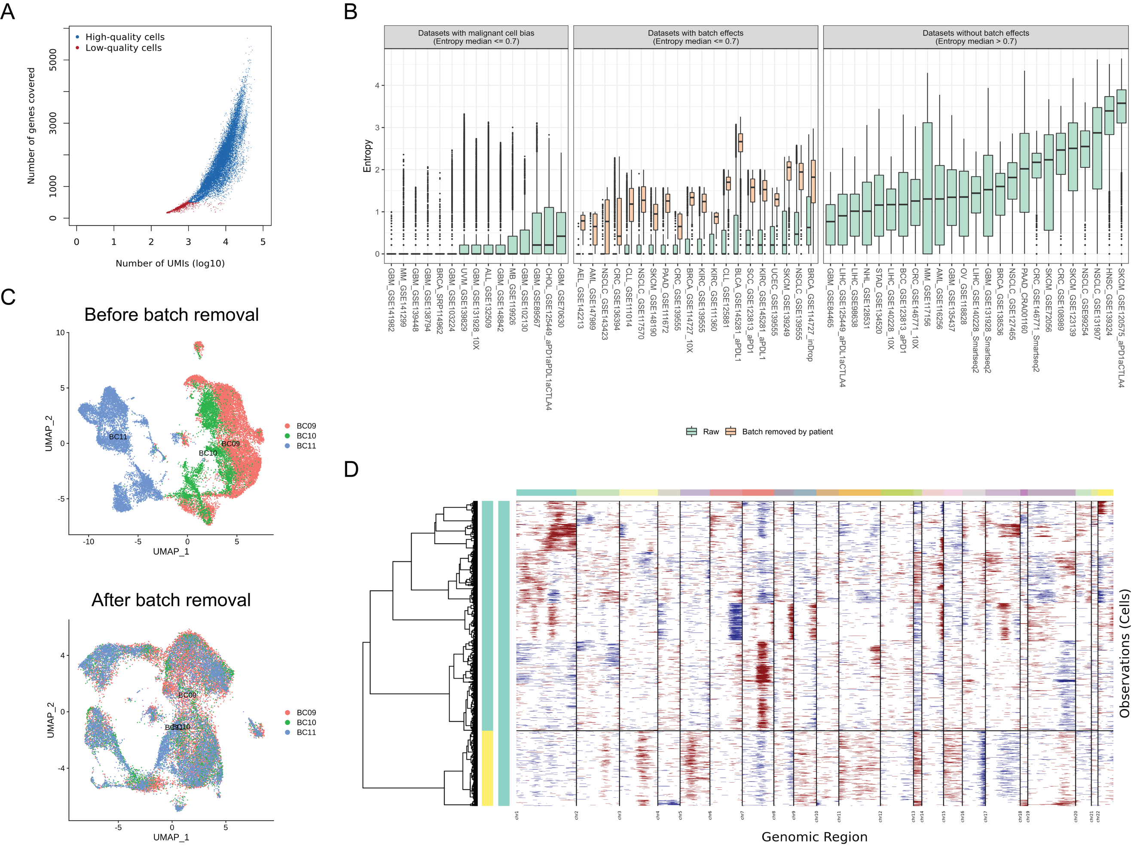

**Data pre-processing.** (A) Quality control for the dataset of MM_GSE141299. The cells with more than 1000 UMI count and 500 gene count are assigned as “High-quality cells” (blue), otherwise “Low-quality cells” (red). (B) Entropy distribution measuring the batch effects in 60 of 79 datasets with batch information. Each dot shows the cell entropy in the corresponding dataset. The 60 datasets were classified into three types, ‘with malignant cell bias’, ‘with batch effects’, and ‘without batch effects’ according to malignant cell proportion and the median entropy of each dataset. The datasets with or without batch effect removal are colored by orange and green, respectively. (C) Batch effect removal for the dataset of BRCA_GSE114727_10X. The cells across patients are shown before batch removal (top) and after batch removal (bottom). (C) InferCNV for malignant cell classification for the dataset of MM_GSE141299. Copy number variations are indicated as gain (red) and loss (blue). The left bar represents the malignant cell (green) and non-malignant cell (yellow).

**Figure S2**

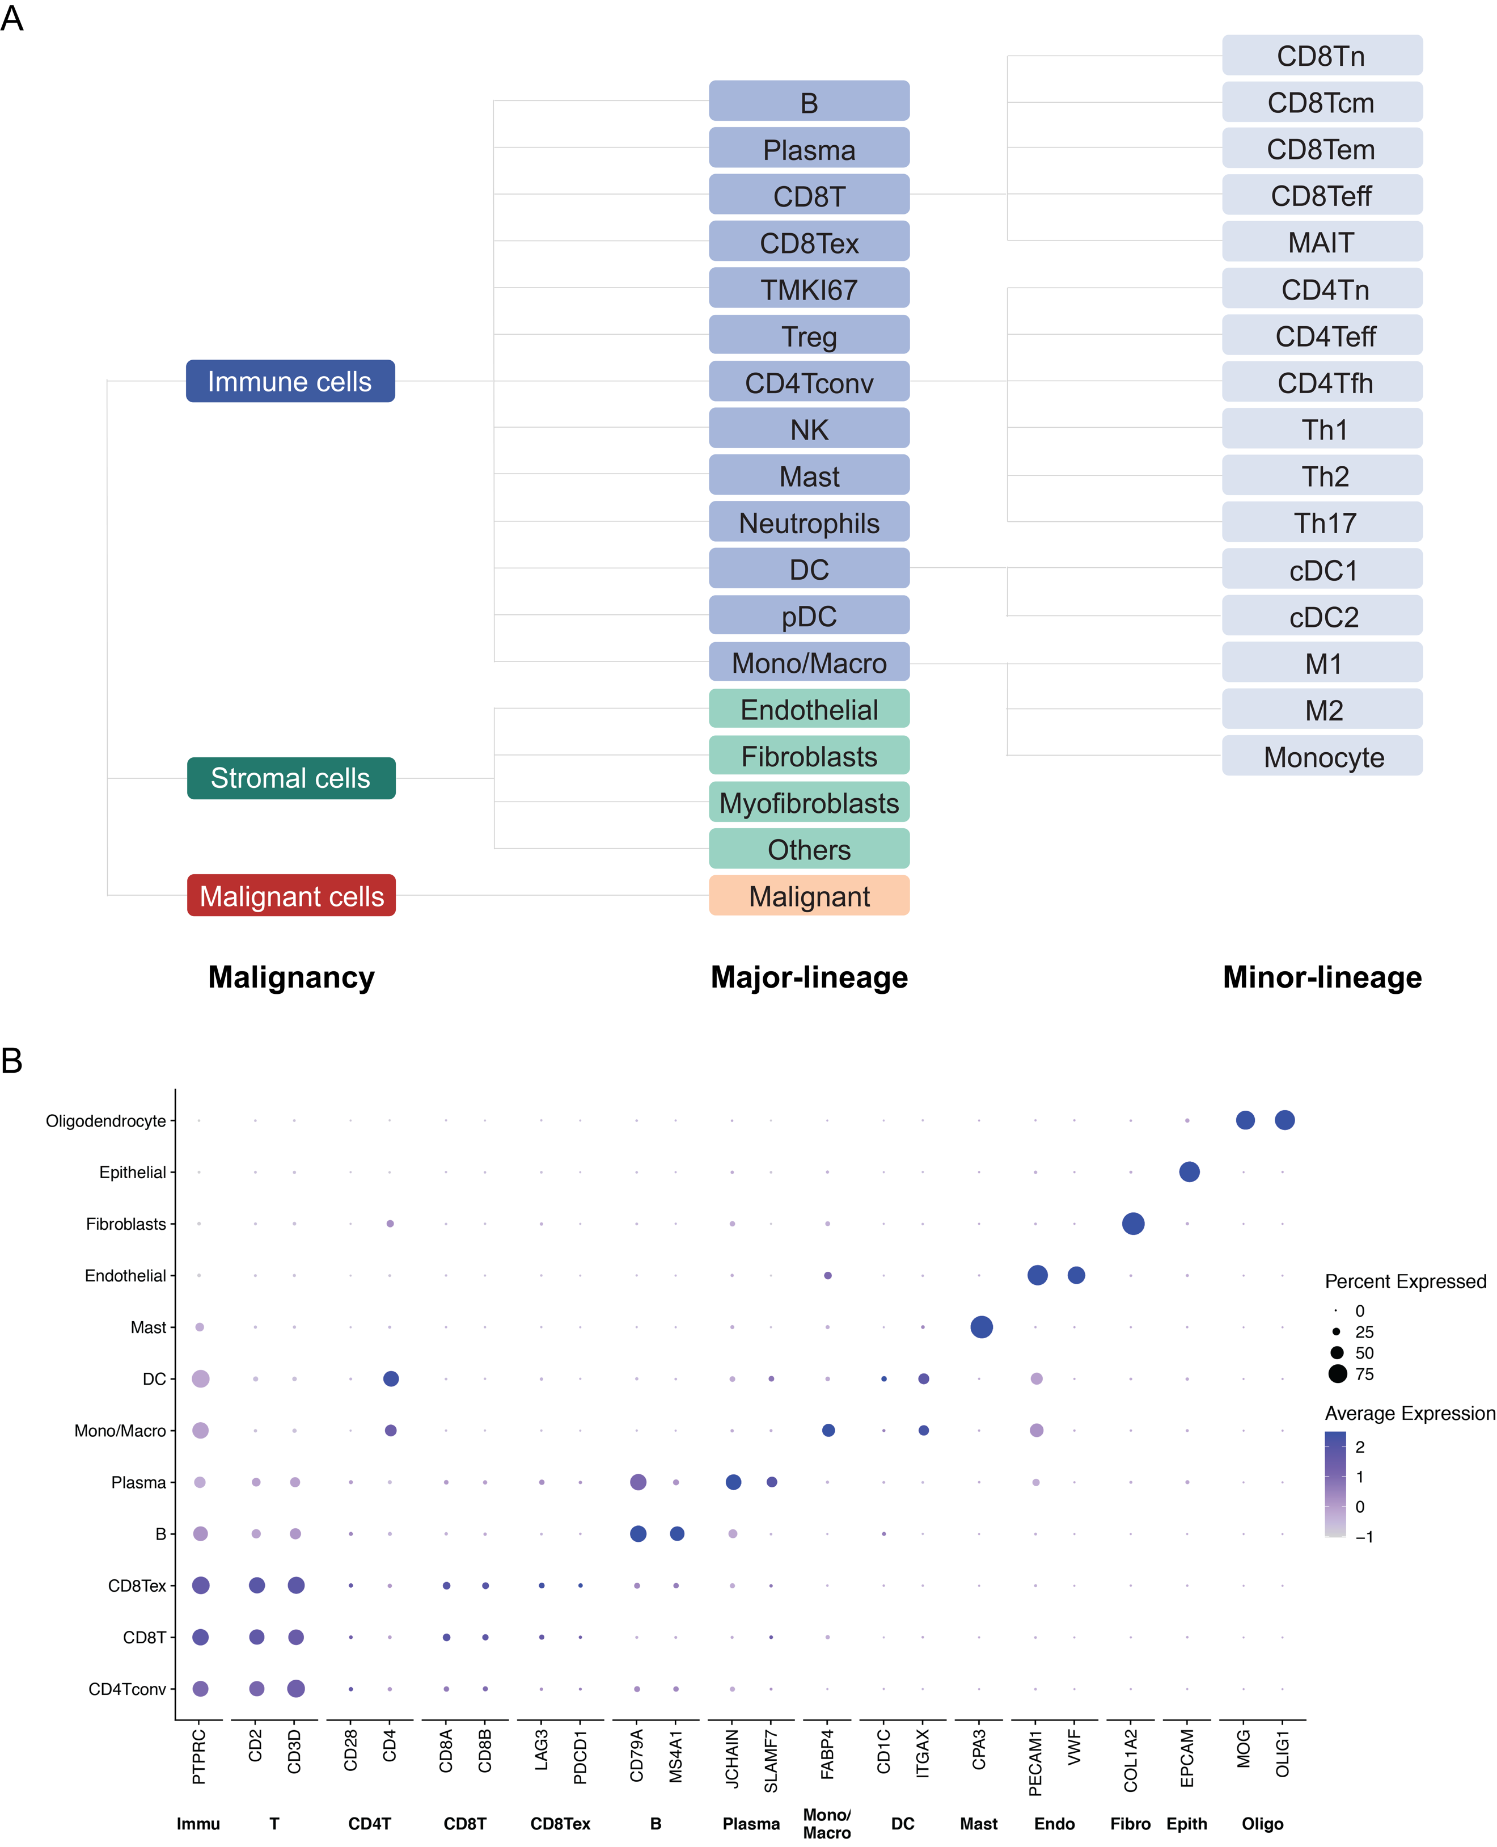

**Cell-type annotation in TISCH.** (A) The hierarchical structure of cell-type annotation. Cell types are annotated at three levels, including malignancy level (malignant cells, stromal cells, and immune cells), major-lineage level, and minor-lineage level. (B) Expression of cell-type specific markers on NSCLC_GSE131907 dataset. The dot size and color represent the percentage of cells with the gene expressed and the average expression value, respectively.

**Figure S3**

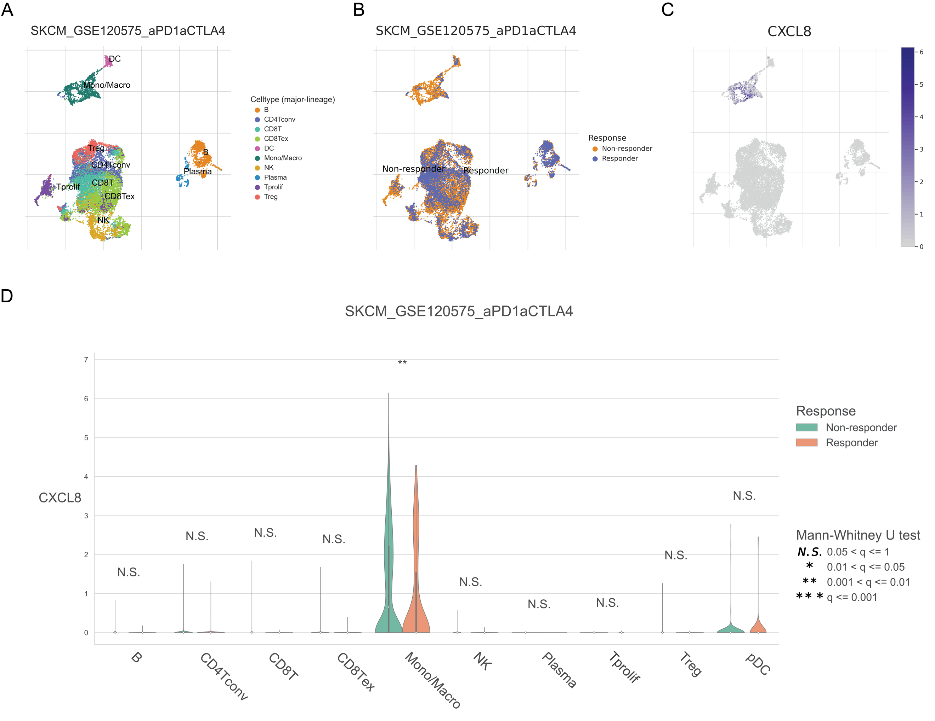

**Example of SKCM_GSE120575_aPD1aCTLA4 in Dataset module.** (A) UMAP visualization of dataset SKCM_GSE120575_aPD1aCTLA4. Colors represent the major-lineage cell-types. (B) UMAP visualization of dataset SKCM_GSE120575_aPD1aCTLA4. Colors represent the response groups. (C) Expression pattern *CXCL8* in datasetSKCM_GSE120575_aPD1aCTLA4. (D) The violin plot is to compare the expression of *CXCL8* between ‘Responder’ (orange) and ‘Non-responder’ (green) across different cell types in an individual cohort SKCM_GSE120575_aPD1aCTLA4. The significance of difference between two groups for each gene in each cell type is evaluated through Mann-Whitney U test and adjusted through Banjamini-Hochberg correction. ‘N.S.’ represents q (adjusted p-value) > 0.05, ‘*’ represents 0.01 < q <= 0.05, ‘**’ represents 0.001 < q <= 0.01, and ‘***’ represents q <= 0.001.

**Figure S4**

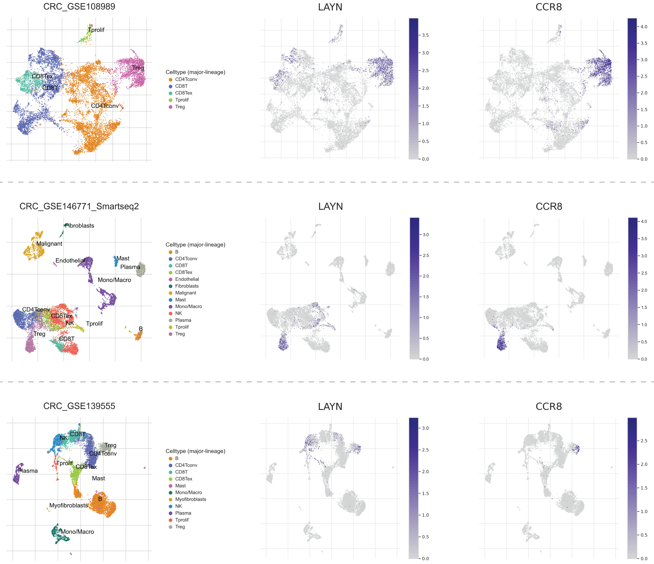

**Comparison of *LYAN* and *CCR8* expression at single-cell resolution across multiple colon cancer cohorts** (CRC_GSE108989, CRC_GSE146771_Smartseq2, and CRC_GSE139555).

**Supplementary Table S1**

The collected data information. TISCH includes 79 high-quality scRNA-seq datasets. The detailed information for each dataset is listed in the table, including dataset name, species, treatment, patient number, cell number, platform, primary/metastatic status, and publication.

|  |  |  |  |  |  |  |  |  |
| --- | --- | --- | --- | --- | --- | --- | --- | --- |
| **Dataset Name** | **Species** | **Treatment** | **Patients** | **Cells** | **Platform** | **Primary/metastatic** | **PMID** | **Data Available** |
| AEL_GSE142213 | Human | None | 2 | 3994 | 10x Genomics | Primary | 32330454 | count |
| ALL_GSE132509 | Human | None | 11 | 37936 | 10x Genomics | Primary | 32415257 | count |
| AML_GSE116256 | Human | None | 21 | 38348 | Smart-seq2 | Primary | 29740158 | count |
| AML_GSE147989 | Human | None | 2 | 7389 | 10x Genomics | Primary | 32601337 | count |
| BCC_GSE123813_aPD1 | Human | Targeted therapy | 11 | 52884 | 10x Genomics | Metastatic | 31359002 | count |
| BLCA_GSE130001 | Human | None | 2 | 4129 | 10x Genomics | Primary | 32111252 | count |
| BLCA_GSE145281_aPDL1 | Human | Immunotherapy | 14 | 58683 | Smart-seq2 | Metastatic | 32405063 | count |
| BRCA_GSE110686 | Human | None | 2 | 6035 | 10x Genomics | Primary, Metastatic | 29942092 | count |
| BRCA_GSE114727_10X | Human | None | 3 | 28678 | 10x Genomics | Primary | 29961579 | count |
| BRCA_GSE114727_inDrop | Human | None | 8 | 19676 | inDrop | Primary | 29961579 | count |
| BRCA_GSE136206_mouse_aPD1aCTLA4 | Mouse | Immunotherapy | NA | 27532 | 10x Genomics | Primary | 31730857 | count |
| BRCA_GSE138536 | Human | None | 8 | 1902 | Smart-seq2 | Primary | 31974247 | TPM |
| BRCA_GSE143423 | Human | None | 2 | 4375 | 10x Genomics | Metastatic | [bioRxiv](https://www.biorxiv.org/content/10.1101/2019.12.30.890517v1) | count |
| BRCA_SRP114962 | Human | None | 8 | 2472 | SNRS | Primary | 29681456 | TPM |
| CHOL_GSE125449_aPD1aPDL1aCTLA4 | Human | Immunotherapy | 10 | 5761 | 10x Genomics | Primary | 31588021 | count |
| CLL_GSE111014 | Human | None | 4 | 30106 | 10x Genomics | Primary | 31996669 | count |
| CLL_GSE125881 | Human | Immunotherapy | 4 | 60528 | 10x Genomics | Primary | 31924795 | count |
| CRC_GSE108989 | Human | None | 12 | 11125 | Smart-seq2 | Primary | 30479382 | TPM |
| CRC_GSE112865_mouse_aPD1 | Mouse | Chemotherapy | NA | 4454 | 10x Genomics | Primary | 30613266 | TPM |
| CRC_GSE120909_mouse_aPD1 | Mouse | Immunotherapy | NA | 1881 | Smart-seq | Primary | 30389797 | count |
| CRC_GSE122969_mouse_aPD1aTIM3 | Mouse | Targeted therapy | NA | 5457 | 10x Genomics | Primary | 30635236 | count |
| CRC_GSE136394 | Human | Immunotherapy | 5 | 67171 | 10x Genomics | Primary, Metastatic | 31484655 | FPKM |
| CRC_GSE139555 | Human | None | 2 | 10112 | 10x Genomics | Primary | 32103181 | count |
| CRC_GSE146771_10X | Human | None | 10 | 43817 | 10x Genomics | Primary | 32302573 | count |
| CRC_GSE146771_Smartseq2 | Human | None | 10 | 10468 | Smart-seq2 | Primary | 32302573 | count |
| GBM_GSE102130 | Human | None | 6 | 3321 | Smart-seq2 | Primary | 29674595 | TPM |
| GBM_GSE103224 | Human | None | 8 | 17185 | Microwell | Primary | 30041684 | count |
| GBM_GSE131928_10X | Human | None | 9 | 13553 | 10x Genomics | Primary | 31327527 | TPM |
| GBM_GSE131928_Smartseq2 | Human | None | 28 | 7930 | Smart-seq2 | Primary | 31327527 | TPM |
| GBM_GSE135437 | Human | None | 19 | 12559 | mCEL-Seq2 | Primary, Metastatic | 31740814 | count |
| GBM_GSE138794 | Human | None | 9 | 18458 | 10x Genomics | Primary | 31554641 | count |
| GBM_GSE139448 | Human | None | 3 | 12152 | 10x Genomics | Primary | 32004492 | count |
| GBM_GSE141982 | Human | None | 2 | 5263 | 10x Genomics | Primary | 32105316 | count |
| GBM_GSE148842 | Human | None | 7 | 111397 | Microwell | Primary | [bioRxiv](https://www.biorxiv.org/content/10.1101/2020.04.22.056341v1) | count |
| GBM_GSE70630 | Human | None | 6 | 4347 | Smart-seq2 | Primary | 27806376 | TPM |
| GBM_GSE84465 | Human | None | 4 | 3533 | Smart-seq2 | Primary | 29091775 | count |
| GBM_GSE89567 | Human | None | 10 | 6341 | Smart-seq2 | Primary | 28360267 | TPM |
| HNSC_GSE103322 | Human | None | 18 | 5902 | Smart-seq2 | Primary | 29198524 | TPM |
| HNSC_GSE139324 | Human | None | 26 | 130721 | 10x Genomics | Primary | 31924475 | count |
| KIRC_GSE111360 | Human | None | 2 | 23130 | 10x Genomics | Primary | 30550791 | count |
| KIRC_GSE145281_aPD1 | Human | Immunotherapy | 4 | 44220 | 10x Genomics | Metastatic | 32103181 | count |
| KIRC_GSE139555 | Human | None | 3 | 49907 | 10x Genomics | Primary | 32405063 | count |
| LIHC_GSE125449_aPDL1aCTLA4 | Human | Immunotherapy | 9 | 3834 | 10x Genomics | Primary | 31588021 | count |
| LIHC_GSE140228_10X | Human | None | 5 | 62530 | 10x Genomics | Primary | 31675496 | count |
| LIHC_GSE140228_Smartseq2 | Human | None | 6 | 7074 | Smart-seq2 | Primary | 31675496 | count |
| LIHC_GSE98638 | Human | None | 6 | 5059 | Smart-seq2 | Primary | 28622514 | count |
| MB_GSE119926 | Human | None | 25 | 7745 | Smart-seq2 | Primary, Metastatic | 31341285 | TPM |
| MCC_GSE117988_aPD1aCTLA4 | Human | Immunotherapy | 1 | 10134 | 10x Genomics | Metastatic | 30250229 | count |
| MCC_GSE118056_aPDL1 | Human | Immunotherapy | 1 | 11024 | 10x Genomics | Primary | 30250229 | count |
| MM_GSE117156 | Human | Targeted therapy | 14 | 24918 | MARS-seq | Primary | 30523328 | count |
| MM_GSE141299 | Human | None | 7 | 16840 | 10x Genomics | Primary | NA | count |
| NET_GSE140312 | Human | None | 1 | 3158 | 10x Genomics | Primary, Metastatic | 32054662 | count |
| NHL_GSE128531 | Human | None | 9 | 30497 | 10x Genomics | Primary | 31010835 | count |
| NSCLC_EMTAB6149 | Human | None | 8 | 40218 | 10x Genomics | Primary | 29988129 | TPM |
| NSCLC_GSE117570 | Human | None | 4 | 11453 | 10x Genomics | Primary | 31033233 | count |
| NSCLC_GSE127465 | Human | None | 7 | 31179 | Smart-seq2 | Primary | 30979687 | count |
| NSCLC_GSE127471 | Human | None | 1 | 1108 | 10x Genomics | Primary | 31061481 | count |
| NSCLC_GSE131907 | Human | None | 44 | 203298 | 10x Genomics | Primary, Metastatic | 32385277 | count |
| NSCLC_GSE139555 | Human | None | 6 | 78829 | 10x Genomics | Primary | 32103181 | count |
| NSCLC_GSE143423 | Human | None | 3 | 12193 | 10x Genomics | Metastatic | [bioRxiv](https://www.biorxiv.org/content/10.1101/2019.12.30.890517v1) | count |
| NSCLC_GSE99254 | Human | None | 14 | 12346 | Smart-seq2 | Primary | 29942094 | count |
| OV_GSE115007 | Human | None | 1 | 6000 | 10x Genomics | Primary | 29967419 | count |
| OV_GSE118828 | Human | None | 9 | 1909 | Smart-seq2 | Primary, Metastatic | 30383866 | count |
| PAAD_CRA001160 | Human | None | 35 | 57443 | 10x Genomics | Primary | 31273297 | count |
| PAAD_GSE111672 | Human | None | 3 | 6122 | inDrop | Primary | 31932730 | count |
| PBMC_30K_10X | Human | Normal | 1 | 29079 | 10x Genomics | Normal | [10X Genomics](https://support.10xgenomics.com/single-cell-gene-expression/datasets/1.1.0/pbmc33k) | count |
| PBMC_60K_10X | Human | Normal | 1 | 63628 | 10x Genomics | Normal | [10X Genomics](https://support.10xgenomics.com/single-cell-gene-expression/datasets/3.1.0/5k_pbmc_NGSC3_aggr) | count |
| PBMC_8K_10X | Human | Normal | 1 | 8488 | 10x Genomics | Normal | [10X Genomics](https://support.10xgenomics.com/single-cell-gene-expression/datasets/2.1.0/pbmc8k) | count |
| SARC_GSE119352_mouse_aPD1aCTLA4 | Mouse | Immunotherapy | NA | 13789 | 10x Genomics | Primary | 30343900 | count |
| SCC_GSE123813_aPD1 | Human | Immunotherapy | 4 | 25891 | 10x Genomics | Metastatic | 31359002 | count |
| SKCM_GSE115978_aPD1 | Human | Immunotherapy | 31 | 7186 | Smart-seq2 | Primary, Metastatic | 30388455 | count |
| SKCM_GSE120575_aPD1aCTLA4 | Human | Immunotherapy | 48 | 16291 | Smart-seq2 | Metastatic | 30388456 | TPM |
| SKCM_GSE123139 | Human | None | 25 | 35494 | MARS-seq | Primary, Metastatic | 30595452 | count |
| SKCM_GSE139249 | Human | None | 4 | 39884 | 10x Genomics | Metastatic | 31801909 | count |
| SKCM_GSE148190 | Human | None | 3 | 27834 | 10x Genomics | Metastatic | 32539073 | count |
| SKCM_GSE72056 | Human | None | 19 | 4645 | Smart-seq2 | Metastatic | 27124452 | TPM |
| STAD_GSE134520 | Human | None | 13 | 41554 | 10x Genomics | Primary | 31067475 | count |
| UCEC_GSE139555 | Human | None | 3 | 12758 | 10x Genomics | Primary | 32103181 | count |
| UVM_GSE139829 | Human | None | 11 | 103703 | 10x Genomics | Primary, Metastatic | 31980621 | count |

**Supplementary Table S2**

The criteria of cell clustering for setting the number of principal components and resolution based on the number of cells.

|  |  |  |
| --- | --- | --- |
| **Number of cellls** | **Number of PCs** | **Resolution** |
| 1000 - 5000 | 15 | 0.6 |
| 5001 - 10000 | 20 | 1 |
| 10001 - 40000 | 30 | 1 |
| 40001 - 80000 | 40 | 1 |
| 80001 - 150000 | 50 | 1 |
| 150001 - | 75 | 1 |

**Supplementary Table S3**

Marker genes collected and curated for major-lineage level of cell-type annotation.

|  |  |
| --- | --- |
| **Major-lineage cell type** | **Markers** |
| B | ABCB4, ADAM28, BACH2, BANK1, BCL7A, BEND5, BLK, BRAF, CD180, CD19, CD1C, CD22, CD37, CD69, CD72, CD79A, CD79B, CR2, CXCR5, EAF2, FAIM3, FCER2, FCGR2B, FCRL2, FRK, GPR18, GUSBP11, HHEX, HLA-DOB, IGHD, IGHM, IGKC, IGLL3P, IL4R, IRF8, KIAA0226L, LINC00921, LTB, LY86, MEP1A, MICAL3, MS4A1, NIPSNAP3B, NMBR, P2RX5, P2RY14, PNOC, PSG2, PTPRCAP, RALGPS2, RASGRP2, SELL, SIK1, SLC12A1, SPIB, STAP1, TCL1A, UGT1A8, VPREB3, ZNF286A, AIM2, ALOX5, CCR6, CD27, CLCA3P, DENND5B, FAM65B, GNG7, IFNA10, IL7, MBL2, NPIPB15, SIT1, SP140, TMEM156, TNFRSF13B, TNFRSF17, TRAF4, ZBTB32 |
| CD4Tconv | ACAP1, ANKRD55, ATHL1, BCL11B, CCR7, CD2, CD247, CD27, CD3D, CD3G, CD40LG, CD7, CXorf57, DPP4, DSC1, EPHA1, FAIM3, FLJ13197, FLT3LG, GAL3ST4, GALR1, GPR1, GRAP2, GZMM, ICOS, IL7R, ITK, LAT, LCK, LEF1, LIME1, LTB, LY9, MAP4K1, MAP4K2, MAP9, RASGRP2, RPL3P7, SERGEF, SH2D1A, SIRPG, TCF7, TRAC, TRAT1, TRAV13-1, TRBC1, UBASH3A, VILL, WNT7A, ZAP70, ZNF204P, ZNF324, CCL5, CCR6, CD28, CD3E, CD4, CD6, CD69, CD96, CTLA4, CTSW, DGKA, EPB41, ETS1, FBXL8, GPR171, GPR25, GZMA, GZMK, KLRB1, NKG7, PBXIP1, PTGER2, PTPRCAP, RASA3, RCAN3, RPL10L, ST8SIA1, TRAV13-2, TRAV21, TRAV8-6, TRAV9-2, ZFP36L2, CCL20, CDC25A, CSF2, CXCL13, GPR19, GZMB, IFNG, IL12RB2, IL17A, IL26, IL2RA, IL3, IL4, IL9, LAG3, LTA, ORC1, PMCH, RRP9, SKA1, TNFRSF4, TNIP3, CHI3L2, CXCR5, FOSB, FZD3, ICA1, IL21, PASK, PDCD1, PVRIG, RGS1, SIK1, SLC7A10, TRIB2, TSHR, ZBTB10 |
| CD8T | BCL11B, CCL5, CD2, CD247, CD27, CD3D, CD3E, CD3G, CD6, CD69, CD7, CD8A, CD8B, CD96, CRTAM, CST7, CTSW, DPP4, DSC1, DUSP2, FAIM3, FLT3LG, GNLY, GPR171, GRAP2, GZMA, GZMB, GZMH, GZMK, GZMM, ICOS, IGKC, IL7R, ITK, KLRB1, KLRC3, KLRC4, KLRD1, KLRF1, KLRK1, LAG3, LCK, LEF1, LIME1, LTB, LY9, MAP4K1, MAP9, NCR3, NKG7, PIK3IP1, PRF1, PTGDR, PTPRCAP, PVRIG, RASA3, RPL3P7, SH2D1A, SIRPG, TCF7, TRAC, TRAT1, TRAV12-2, TRAV13-1, TRBC1, TRDC, UBASH3A, ZAP70 |
| CD8Tex | BCL11B, CCL5, CD2, CD247, CD27, CD3D, CD3E, CD3G, CD6, CD69, CD7, CD8A, CD8B, CD96, CRTAM, CST7, CTSW, DPP4, DSC1, DUSP2, FAIM3, FLT3LG, GNLY, GPR171, GRAP2, GZMA, GZMB, GZMH, GZMK, GZMM, ICOS, IGKC, IL7R, ITK, KLRB1, KLRC3, KLRC4, KLRD1, KLRF1, KLRK1, LAG3, LCK, LEF1, LIME1, LTB, LY9, MAP4K1, MAP9, NCR3, NKG7, PIK3IP1, PRF1, PTGDR, PTPRCAP, PVRIG, RASA3, RPL3P7, SH2D1A, SIRPG, TCF7, TRAC, TRAT1, TRAV12-2, TRAV13-1, TRBC1, TRDC, UBASH3A, ZAP70, PDCD1, CTLA4, TIGIT, HAVCR2 |
| DC | AIF1, ALOX15, C1orf54, CCDC102B, CCL13, CCL17, CCL18, CCL22, CD1A, CD1B, CD1C, CD1E, CD209, CD33, CD68, CLEC10A, CLEC4A, CLEC7A, CLIC2, DHRS11, EGR2, FAM198B, FCER1A, FCER2, FLVCR2, FPR3, FZD2, HLA-DQA1, IGSF6, MMP12, NCF2, PLA2G7, PPFIBP1, RNASE6, SCN9A, SLAMF8, SLC15A3, TMEM255A, TREM2, ARHGAP22, BIRC3, CCL1, CCL19, CCL20, CCL5, CCL8, CCR7, CD80, CD86, CHST7, CXCL10, CXCL11, CYP27A1, DHX58, EBI3, ETV3, HESX1, HTR2B, IDO1, IFI44L, IL12B, IL2RA, KYNU, LAMP3, MAP3K13, MSC, NR4A3, PDCD1LG2, PLA1A, PTGIR, RASSF4, RSAD2, SIGLEC1, SLC2A6, SLCO5A1, ST3GAL6, TNFAIP6, TNFRSF11A, TNFRSF4 |
| Endothelial | PECAM1, VWF, ENG |
| Fibroblasts | FAP, PDPN, MMP2, PDGFRA, THY1, MMP11, PDGFRL, TGFB3, COL1A2, DCN, COL3A1, COL6A1 |
| Mast | ATP8B4, BMP2K, BPI, C3AR1, CD33, CEACAM8, CLC, CMA1, CPA3, CRISP3, CTSG, FAM124B, FAM174B, FCER1A, GFI1, HDC, HPGDS, IL18R1, LTC4S, MS4A2, MS4A3, MYB, NOX3, NTRK1, P2RX1, P2RY14, PAQR5, PRG2, RAB27B, RGS13, SEPT8, SLC12A8, ST8SIA1, STAP1, STXBP6, TPSAB1, CCL1, CCL20, CCL4, CSF2, CXCL3, GZMB, HOXA1, IL1A, IL1B, IL1RL1, IL3, IL5, LINC00597, MARCH3, TEC |
| Mono/Macro | AIF1, APOBEC3A, AQP9, ASGR1, ASGR2, BST1, C5AR1, CCR2, CD1D, CD33, CD68, CDA, CFP, CHST15, CLEC4A, CLEC7A, CREB5, CSF3R, FAM198B, FCN1, FES, FOSB, FPR1, FZD2, HCK, HK3, HNMT, HPSE, IGSF6, LILRA2, LILRA3, LILRB2, LST1, MEFV, MNDA, MS4A6A, NCF2, NFE2, NLRP3, NOD2, P2RY13, PADI4, RNASE2, RNASE6, S100A12, SLC15A3, TLR2, TLR7, TLR8, UPK3A, VNN1, VNN2, ACP5, ADAMDEC1, BHLHE41, CCDC102B, CCL18, CCL22, CCL7, CHI3L1, COL8A2, CSF1, CXCL3, CXCL5, CYP27A1, DCSTAMP, GPC4, MARCO, MMP9, PLA2G7, PPBP, QPCT, SLAMF8, SLC12A8, TNFSF14, TREM2, ACHE, APOL3, APOL6, ARRB1, CCL19, CCL5, CCL8, CCR7, CD38, CD40, CLIC2, CXCL10, CXCL11, CXCL13, CXCL9, CYP27B1, DHX58, EBI3, GGT5, HESX1, IDO1, IFI44L, IL2RA, KIAA0754, KYNU, LAG3, LAMP3, PLA1A, PTGIR, RASSF4, RSAD2, SIGLEC1, SLAMF1, SLC2A6, SOCS1, TNFAIP6, TNIP3, TRPM4, ALOX15, CCL13, CCL14, CCL23, CD209, CD4, CLEC10A, CRYBB1, FRMD4A, GSTT1, HRH1, HTR2B, NME8, NPL, PDCD1LG2, RENBP, WNT5B |
| Myofibroblasts | ACTA2, MCAM, MYLK, MYL9, IL6, PDGFA |
| Neutrophils | AIF1, APOBEC3A, AQP9, BTNL8, C5AR1, CAMP, CASP5, CCR3, CDA, CEACAM3, CFP, CHI3L1, CHST15, CLC, CREB5, CSF3R, CXCR1, CXCR2, DPEP2, EMR2, EMR3, FAM212B, FCGR3B, FFAR2, FPR1, FPR2, GPR97, HAL, HSPA6, IGSF6, IL18RAP, LILRA2, LILRB2, LST1, MAK, MEFV, MGAM, MMP25, MNDA, MXD1, NCF2, NFE2, P2RY13, P2RY14, PADI4, PGLYRP1, PLEKHG3, QPCT, REPS2, S100A12, STEAP4, TLR2, TLR8, TNFAIP6, TNFRSF10C, TREM1, TREML2, VNN1, VNN2, VNN3 |
| NK | BPI, CAMP, CCL5, CD160, CD2, CD244, CD247, CD7, CD96, CDHR1, CEACAM8, CST7, CTSW, DEFA4, ELANE, GFI1, GNLY, GZMA, GZMB, GZMH, GZMK, GZMM, IL12RB2, IL18R1, IL18RAP, IL2RB, KIR2DL1, KIR3DL2, KLRB1, KLRC3, KLRC4, KLRD1, KLRF1, KLRK1, LCK, MGAM, MS4A3, NAALADL1, NKG7, NME8, PLEKHF1, PRF1, PRR5L, PTGDR, PTPRCAP, PVRIG, S1PR5, SH2D1A, TBX21, TEP1, TRBC1, TRDC, TTC38, TXK, ZAP70, ZNF135, APOBEC3G, APOL6, CCL4, CCND2, CD69, CDK6, CSF2, DPP4, FASLG, GPR171, GPR18, GRAP2, IFNG, KIR2DL4, KIR2DS4, LTA, LTB, NCR3, OSM, PTGER2, SOCS1, TNFSF14 |
| pDC | AIF1, ALOX15, C1orf54, CCpDC102B, CCL13, CCL17, CCL18, CD1A, CD1B, CD1C, CD1E, CD33, CD68, CLEC10A, CLEC4A, CLEC7A, CLIC2, DHRS11, EGR2, FAM198B, FCER1A, FCER2, FLVCR2, FPR3, FZD2, HLA-DQA1, IGSF6, MMP12, NCF2, PLA2G7, PPFIBP1, RNASE6, SCN9A, SLAMF8, SLC15A3, TMEM255A, TREM2, CLEC4C, IRF7, LILRB4, Siglech, ARHGAP22, BIRC3, CCL1, CCL19, CCL20, CCL5, CCL8, CCR7, CD80, CD86, CHST7, CXCL10, CXCL11, CYP27A1, DHX58, EBI3, ETV3, HESX1, HTR2B, IDO1, IFI44L, IL12B, IL2RA, KYNU, LAMP3, MAP3K13, MSC, NR4A3, PpDCD1LG2, PLA1A, PTGIR, RASSF4, RSAD2, SIGLEC1, SLC2A6, SLCO5A1, ST3GAL6, TNFAIP6, TNFRSF11A, TNFRSF4 |
| Plasma | ABCB9, AMPD1, ANGPT4, ATXN8OS, C11orf80, CCR10, CD27, CD38, CD79A, DENND5B, EAF2, FCRL2, GNG7, GPR25, GUSBP11, HIST1H2AE, HIST1H2BG, HLA-DOB, IGHD, IGHE, IGHM, IGKC, IGLL3P, KCNA3, KCNG2, LIME1, LOC100130100, MAN1A1, MANEA, MAST1, MROH7, MZB1, P2RX5, PAX7, PDK1, PNOC, RASGRP3, REN, RGS13, RPL3P7, SIK1, SPAG4, ST6GALNAC4, TGM5, TMEM156, TNFRSF17, UGT2B17, ZBP1, ZNF165 |
| TMKI67 | BCL11B, CD2, CD247, CD27, CD28, CD3D, CD3E, CD3G, CD6, CD7, CD8A, CD8B, CD96, CXCR6, FLT3LG, FYN, GIMAP4, GPR171, GZMK, GZMM, ICOS, ITK, LCK, LIME1, PRKCH, PSTPIP1, SH2D1A, SIRPG, TNFRSF9, TRAC, TRAT1, TRBC1, TRBC2, UBASH3A, ZAP70, AURKA, BIRC5, BUB1, CCNA2, CCNB1, CDC20, CDK1, CDKN3, FEN1, HMGB2, MCM2, MCM5, MCM6, MYBL2, NUSAP1, PCNA, PLK1, TOP2A, ZWINT |
| Treg | BARX2, BCL11B, CD2, CD247, CD27, CD28, CD3D, CD3E, CD3G, CD4, CD5, CD6, CD70, CD96, CEMP1, CLEC2D, CTLA4, DGKA, DPP4, EFNA5, FOXP3, FRMD8, GPR1, GPR171, GPR19, GZMM, HIC1, HMGB3P30, ICOS, IL2RA, IL2RB, ITK, KIRREL, LAIR2, LCK, LILRA4, LOC126987, LTB, MAP4K1, MBL2, NPAS1, NTN3, PCDHA5, PLCH2, PMCH, PTGIR, PTPRG, RCAN3, RYR1, SEC31B, SEPT5, SH2D1A, SIRPG, SIT1, SKAP1, SPOCK2, SSX1, TRAC, TRAT1, TRAV9-2, TRBC1, TYR, UBASH3A, ZAP70 |

**Supplementary Table S4**

Marker genes collected and curated for minor-lineage level of cell-type annotation.

|  |  |
| --- | --- |
| **Minor-lineage cell type** | **Markers** |
| CD4Teff | CD3D, CD3E, CD3G, CD4, CTSW, CX3CR1, GNLY, GZMH, KLRG1, NKG7, PRF1, S1PR1, S1PR5, TBX21 |
| CD4Tn | CCR7, CD27, CD28, CD3D, CD3E, CD3G, CD4, LEF1, RUNX3, S1PR1, SELL, TCF7, ZBTB7B |
| CD8Tcm | BCL6, BCL6B, BMI1, CCL5, CCR7, CD27, CD28, CD3D, CD3E, CD3G, CD44, CD8A, CD8B, CXCR3, EOMES, GPR183, GZMA, GZMK, IL15RA, IL2RB, IL2RG, IL7R, MBD2, PRF1, S1PR1, SELL, TRD, TRG |
| CD8Teff | CD3D, CD3E, CD3G, CD8A, CD8B, CX3CR1, EOMES, FCGR3A, FGFBP2, FOS, GZMH, IFNG, JUN, KLRG1, PRF1, S1PR1, S1PR5, TBX21, TNF |
| CD8Tem | CCR7, CD3D, CD3E, CD3G, CD44, CD8A, CD8B, CXCR3, CXCR4, FGFBP2, GZMK, IL15RA, IL2RB, IL2RG, IL7R, KLRD1, KLRG1, PRDM1, TRD, TRG |
| CD8Tn | CCR7, CD27, CD28, CD3D, CD3E, CD3G, CD8A, CD8B, IL7R, LEF1, RUNX3, S1PR1, SELL, TCF7, ZBTB7B |
| cDC1 | BATF3, BTLA, CADM1, CD226, CLEC9A, DPP4, ID2, IRF8, THBD, TLR3, XCR1, CCL22, FLT3, CD8A, CD207, ITGAE |
| cDC2 | CCL22, CD209, CCL17, HSD11B1, CCL13, PPFIBP2, NPR1, CD1B, VASH1, F13A1, CD1E, MMP12, FABP4, CLEC10A, SYT17, MS4A6A, CTNS, GUCA1A, CARD9, ABCG2, CD1A, PPARG, RAP1GAP, SLC7A8, GSTT1, PDXK, FZD2, CSF1R, HS3ST2, CH25H, LMAN2L, SLC26A6, BLVRB, NUDT9, PREP, TM7SF4, TACSTD2, CD1C, CCL1, EBI3, INDO, LAMP3, OAS3, IL3RA |
| M1 | SIGLEC1, CCR5, CD33, CD40, CD63, CD68, CD80, CD86, CLEC7A, CXCL10, CXCL11, CXCL2, CXCL9, ENG, FCGR1A, FCGR1B, FCGR1C, FCGR2A, FCGR2B, FCGR3A, FCGR3B, FUT4, IDO, LILRA4, MerTK, NOS2, SOCS1, SOCS3, TLR2, TLR4, TREM1, FCER1G, FCER2A, HLA-DRA |
| M2 | SIGLEC1, ARG1, CCL22, CCR5, CD163, CD200R1, CD209, CD33, CD40, CD63, CD68, CD80, CD86, CXCL10, CXCL11, CXCL2, CXCL9, ENG, FCER2, FUT4, ITGAM, JUN, LILRA4, MRC1, MSR1, PPARG, TGM2, TLR2, TLR4, TREM1, TREM2, FCER1G, FCER2A, HLA-DRA |
| MAIT | CD3D, CD3E, CD3G, CD8A, CD8B, KLRB1, NCR3, RORA, RORC, SLC4A10, ZBTB16 |
| Monocyte | SIGLEC1, CCR5, CD14, CD33, CD40, CD63, CD68, CD80, CD86, CD93, CSF1R, CXCL10, CXCL11, CXCL2, CXCL9, ENG, FCGR3A, FUT4, ITGA5, ITGAM, ITGAX, LILRA4, S100A9, TLR2, TLR4, TREM1, S100A8 |
| pDC | CD123, CD14, CD19, CD1A, CLEC4C, DR6, FECR1, GZMB, HLA-DRA, IFNA1, IFNB1, IL10, IL3RA, IL6, ILT3, ILT7, IRF4, IRF7, IRF8, ITGAX, LILRB4, MS4A1, NCAM1, NRP1, PTPRC, Siglech, SPIB, TCF4, TLR7, TLR9, TNF, ZEB2, FLT3 |
| Plasma | ABCB9, AMPD1, ANGPT4, ATXN8OS, C11orf80, CCR10, CD27, CD38, CD79A, DENND5B, EAF2, FCRL2, GNG7, GPR25, GUSBP11, HIST1H2AE, HIST1H2BG, HLA-DOB, IGHD, IGHE, IGHM, IGKC, IGLL3P, KCNA3, KCNG2, LIME1, LOC100130100, MAN1A1, MANEA, MAST1, MROH7, MZB1, P2RX5, PAX7, PDK1, PNOC, RASGRP3, REN, RGS13, RPL3P7, SIK1, SPAG4, ST6GALNAC4, TGM5, TMEM156, TNFRSF17, UGT2B17, ZBP1, ZNF165 |
| Tfh | BCL6, BLTA, CD200, CD3D, CD3E, CD3G, CD4, CD40LG, CXCR3, CXCR5, ICA1, ICOS, IL21R, IL6ST, MAGEH1, PDCD1, PTPN13, SLAM, STAT3, TNFSF4, TOX, TOX2 |
| Th1 | BHLHE40, CCR1, CCR5, CD3D, CD3E, CD3G, CD4, CD94, CXCL13, CXCR3, CXCR6, GZMB, HAVCR2, ICOS, IFNG, IFNGR1, IFNGR2, IGFLR1, IL12RB1, IL12RB2, IL18R1, ITGAE, PDCD1, STAT1, STAT4, TBX21, TNFSF11 |
| Th17 | CAPG, CCR6, CD3D, CD3E, CD3G, CD4, CTSH, FURIN, IL23R, IL17A, IL1R1, IL1R2, IL26, ITGAE, KLRB1, RORA, RORC, STAT3 |
| Th2 | BHLHE41, CCR4, CCR8, CD3D, CD3E, CD3G, CD4, CXCR4, GATA3, GPR44, HAVCR1, IL17RB, IL1RL1, IL4R, MAF, PTGDR2, STAT6 |
| Treg | CD3D, CD3E, CD3G, CD4, CDC25B, CTLA4, FOXO1, FOXO3, FOXP3, IKZF2, IL10RA, IL2RA, RTKN2, S1PR4, STAT5A, STAT5B |